AmyJane Reilly, Trey DeaBueno

1. Make a git repository in GitHub
   1. Make sure to use the Python .gitignore template and no license
   2. Click on this button to get the URL  
       
2. Clone git repository
   1. In Visual Studio Code, click on the hamburger menu
      1. Click file à New Window
      2. When the window opens, click clone Git repository
      3. Paste the URL in and clone it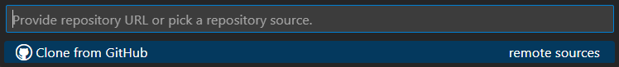
3. Create and access the Python virtual environment
   1. python -m venv djvenv
   2. PowerShell: ./djvenv/Scripts/Activate.ps1  
      Command Prompt: ./djvenv/Scripts/activate.bat
4. Upgrade PIP:  
   py -m pip install --upgrade pip
5. Install Django by running:  
   python -m pip install Django
6. Install Django Bootstrap by running:  
   python -m pip install django-bootstrap-v5
7. Install Pillow by running:  
   python -m pip install pillow
8. Make sure Django successfully installed by running:  
   django-admin --version
   1. You should see the version of Django (4.2.7 as of November 2023).
9. Create Django project and reorganize the files:
   1. django-admin startproject django_project
   2. mv django_project/manage.py ./
   3. mv django_project/django_project/* django_project
   4. rm -r django_project/django_project/
10. Create Django app by running:  
    django-admin startapp <app name>
11. Run server (ignore the warnings)
    1. py manage.py runserver
    2. Go to the following url in your web browser: <http://localhost:8000/>   
       You should see:

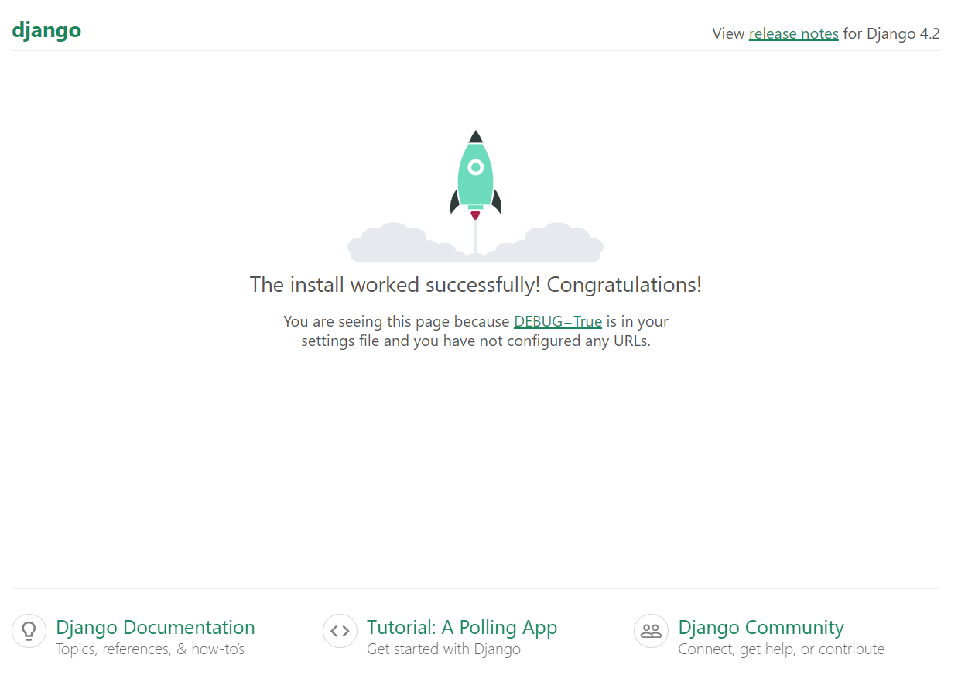

1. Open the virtual environment again and create requirements.txt:
   1. pip freeze > requirements.txt
2. In the .gitignore file, add the line to the bottom of the file:  
   /djvenv
3. Migrate the database by running:  
   python manage.py migrate
4. Create a superuser by running:  
   python manage.py createsuperuser
5. Run the server by running:  
   python manage.py runserver
6. Configure Settings: Edit your django_project's settings.py file, add your app to the INSTALLED_APPS list and add support for authenticating users:

INSTALLED_APPS = [

# ...

'django.contrib.auth',

'django.contrib.contenttypes',

'django.contrib.sessions',

'django.contrib.messages',

'Django.contrib.staticfiles',

# Add your app name here

'<app_name>',

# Add your Bootstrap here

'bootstrap5',

]

# Add support for authenticating users

AUTHENTICATION_BACKENDS = [

'django.contrib.auth.backends.ModelBackend',

]

# Import os underneath the Path import:

import os

Go down to static files and replace it with:

# Static files (CSS, JavaScript, Images)

# <https://docs.djangoproject.com/en/4.2/howto/static-files/>

STATIC_URL = 'static/'

# Add these lines

MEDIA_URL = '/images/'

MEDIA_ROOT = os.path.join(BASE_DIR, 'images')

1. Create a folder named “static” under the folder with the app name
   1. Create a folder named “images” inside it
   2. If you have a logo, copy it to the images folder with the name “navbar_logo.png”
2. Create a folder named “templates” under the folder with the app name
   1. Create a folder inside named with the same name as your app
   2. Add a file inside named “base_template.html”

{% load static %}

<!DOCTYPE html>

<html lang="en">

<head>

<title>Title</title>

<meta charset="utf-8" />

<meta name="viewport" content="width=device-width, initial-scale=1" />

{% load bootstrap5 %} {% bootstrap_css %} {% bootstrap_javascript %}

</head>

<body>

<nav class="navbar navbar-expand-lg navbar-light bg-light lead">

<div class="container-fluid">

<a class="nav-link" href="{% url 'index' %}"

><img src="{% static 'images/navbar_logo.png' %}" class="mx-2"

/></a>

<button

class="navbar-toggler"

type="button"

data-bs-toggle="collapse"

data-bs-target="#navbarNav"

aria-controls="navbarNav"

aria-expanded="false"

aria-label="Toggle navigation"

>

<span class="navbar-toggler-icon" />

</button>

<div class="collapse navbar-collapse" id="navbarNav">

<ul class="navbar-nav">

<li class="nav-item">

<a class="nav-link" href="{% url 'index' %}">Home</a>

</li>

</ul>

</div>

</div>

</nav>

<!-- add block content from html template -->

<div class="m-4">{% block content %} {% endblock %}</div>

</body>

</html>

* 1. Add a file inside named “index.html” and replace app_name with your app name

<!-- inherit from base.html -->

{% extends "<app_name>/base_template.html" %}

<!-- Replace block content in base_template.html -->

{% block content %}

<h1>Home Page</h1>

{% endblock %}

1. Create the following files in the app folder replacing app_name with your app name:
   1. forms.py

from django.forms import ModelForm

# Create forms here

* 1. urls.py

from django.urls import path

from django.conf import settings

from django.conf.urls.static import static

from . import views

urlpatterns = [

# path function defines a url pattern

# '' is empty to represent based path to app

# views.index is the function defined in views.py

# name = 'index' parameter is to dynamically create url

path('', views.index, name='index'),

]

if settings.DEBUG:

urlpatterns += static(settings.MEDIA_URL, document_root=settings.MEDIA_ROOT)

* 1. views.py

from django.shortcuts import render

# Create your views here.

def index(request):

return render(request, '<app_name>/index.html')

1. In django_project/urls.py, replace the code with:

from django.contrib import admin

from django.urls import path, include

urlpatterns = [

path('admin/', admin.site.urls),

path('', include('<app_name>.urls'))

]